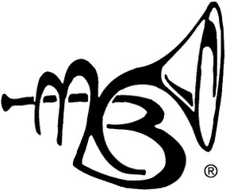MIDLAND CONCERT BAND
2023-2024 HIGH SCHOOL BAND SCHOLARSHIPS

MCB is pleased to announce this year’s scholarship program. We have six endowed or directed funds that are up to $1000 each. One award is for flute, two are for low brass students, one for a percussionist, and two are available to any band instrument. See the attached sheet for information. The MCB also has funds to award up to 5 more scholarships this winter. If you are interested, please fill out the form and either email it to sue@gessford.us or mail it to Sue Gessford, c/o MCB, PO Box 2300, Midland, MI 48641 before February 2, 2024. You will be notified of our decision by early March. Students will be encouraged to perform with the band at our Spring Concert at the MCFTA on Sunday, May 5.
Rehearsals will be Thursdays beginning April 4 at Dow High from 7:15-9:30 PM. Students will be expected to attend at least four of the 5 rehearsals to play the concert. If you are playing in an April pit orchestra, or if you are in a spring sport, please check for game /show conflicts. Due to the short rehearsal period this spring, MCB is not requiring students to play with us, but those available for four or more rehearsals will be given priority.
Scholarship money can be used for private lessons, an instrument upgrade, or a camp such as Blue Lake or Interlochen, or sent directly to a college music program in your name. If you have any questions, please contact Director of Education, Sue Gessford at sue@gessford.us. Please write legibly.

Name_____________________________Current Grade (9-12)______Instrument_________________

Address (include town and zip)___________________________________________________________

Phone where you can be reached________________________________Email__________________________________________

Parent or Guardian__________________________________________________________________________

Phone____________________________________Email______________________________

School______________________________ Band Director____________________________

Please use the back of this paper to write a short essay describing your musical experience,
any leadership roles in your band program, and how you would use the award. Tell us whether or not you can attend the rehearsals with MCB. Please ask your band director to email us a brief recommendation regarding your classroom participation and musical ability. Have a parent or guardian sign this sheet as well.
This form and the recommendation are due back to us by February 2. Good luck!!

I approve of my music student’s scholarship application, and I will support his/her commitment to attending rehearsals and practicing.
Parent/Guardian Signature ___________________________________________Date_________

